TOPIC 5.5 : DIJKSTRA'S ALGORITHM USING ADJACENCY MATRIX
Problem Statement
Given a graph represented by an adjacency matrix, implement Dijkstra's Algorithm to find the shortest path from a given source vertex to all other vertices in the graph.
The graph is represented as an adjacency matrix where graph[i][j] denotes the weight of the edge from vertex i to vertex j.
If there is no edge between vertices i and j, the value is Infinity (or a very large number).
Test Case 1
Input:
n = 5
graph = [[0, 10, 3, Infinity, Infinity],
[Infinity, 0, 1, 2, Infinity],
[Infinity, 4, 0, 8, 2],
[Infinity, Infinity, Infinity, 0, 7],
[Infinity, Infinity, Infinity, 9, 0]]
source = 0
Output: [0, 7, 3, 9, 5]
Test Case 2
Input:
n = 4
graph = [[0, 5, Infinity, 10],
[Infinity, 0, 3, Infinity],
[Infinity, Infinity, 0, 1],
[Infinity, Infinity, Infinity, 0]]
source = 0
Output: [0, 5, 8, 9]
Aim
To write a program that finds the shortest distance from a given source vertex to all other vertices using Dijkstra's Algorithm on an adjacency matrix representation of a graph.
Algorithm
- Start
- Initialize an array dist[] with Infinity values and set dist[source] = 0
- Maintain a visited set to track processed vertices
- Repeat n times:
  - Select the unvisited vertex u with the smallest dist[u]
  - Mark u as visited
  - Update distances of all adjacent vertices v of u:
If dist[u] + graph[u][v] < dist[v], update dist[v]
- After all vertices are processed, dist[] contains the shortest path from source to all vertices
- Stop
Input and Output
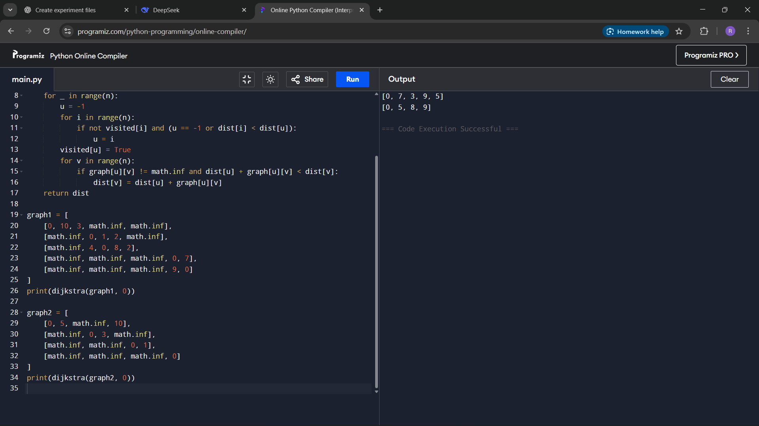
Result
The program successfully computes the shortest path distances from the source vertex to all other vertices using Dijkstra's Algorithm.
Performance Analysis
Time Complexity: O(n^2) for adjacency matrix
Space Complexity: O(n) for distance and visited arrays

